EXPERIMENT NO. 8
—-----------------------------------------------------------------------------------------------------------------------Basic File Operations

NAME :Srushti Ghewade
Batch :A
Div :CE2
PRN :B25CE1085
Branch :Computer Engineering

RESEARCH
This program is based on the fundamental concept of File Handling in C, which allows data to be stored permanently in secondary storage (like a text file).
Research involves understanding:
Why File Handling Is Needed?
- To store data permanently.
- To retrieve data even after the program ends.
- To read/write large amounts of data efficiently.

ANALYSIS
The program runs an infinite loop providing a menu with four operations:
Case 1: Write to File using fprintf
Case 2: Read Using fscanf
Case 3: Display Character by Character using fgetc
Case 4: Exit the Program
IDEATE
PROBLEM STATEMENT -
Create a C program to perform various file operations, including reading from a file, writing to a file, and displaying the contents of a file. The program should provide options for the user to select the desired operation from a menu. Upon selecting an operation, the program should execute the corresponding functionality using appropriate file handling techniques. Additionally, the program should handle errors such as file not found or permission issues gracefully and provide informative messages to the user.

BUILD
#include <stdio.h>
int main()

{
FILE *fp;
int choice;
char filename[]="data.txt";
char text[200];
char ch;

while (1) {

printf("\n========= MENU ==========");
printf("\n1.Write to data.txt(fprintf)");
printf("\n2.Read from data.txt(fscanf)");
printf("\n3.Display data.txt(fgetc - char by char)");
printf("\n4.Exit");
printf("\nEnter your choice: ");
scanf("%d",&choice );

switch (choice){

case 1:

fp = fopen(filename,"w");
if(fp==NULL) {

printf("Error opening file!\n");
break;
}

printf("Enter text to write: ");
getchar(); //Clear input buffer
fgets(text,200,stdin); //Read line
fprintf(fp,"%s",text); //Write using fprintf

fclose(fp);
printf("Data written to data.txt\n");
break;

case 2:
fp = fopen(filename,"r");
if(fp==NULL) {
printf("data.txt not found!\n");
break;

}

printf("\n--- Reading using fscanf ---\n");
while(fscanf(fp,"%199[^\n]\n",text)!= EOF) {
printf("%s\n",text);
}
fclose(fp);
break;

case 3:

fp = fopen(filename,"r");
if(fp==NULL) {
printf("data.txt not found!\n");
break;
}
printf("\n--- Displaying character by character ---\n");
while((ch=fgetc(fp))!= EOF) {
putchar(ch);
}

fclose(fp);
break;

case 4:
printf("Exiting...\n");
return 0;

default:
printf("Invalid choice!\n");
}
}
return 0;
}

TEST
INPUT
#include <stdio.h>
int main()

{
FILE *fp;
int choice;
char filename[]="data.txt";
char text[200];
char ch;

while (1) {

printf("\n========= MENU ==========");
printf("\n1.Write to data.txt(fprintf)");
printf("\n2.Read from data.txt(fscanf)");
printf("\n3.Display data.txt(fgetc - char by char)");
printf("\n4.Exit");
printf("\nEnter your choice: ");
scanf("%d",&choice );

switch (choice){

case 1:

fp = fopen(filename,"w");
if(fp==NULL) {

printf("Error opening file!\n");
break;
}

printf("Enter text to write: ");
getchar(); //Clear input buffer
fgets(text,200,stdin); //Read line
fprintf(fp,"%s",text); //Write using fprintf

fclose(fp);
printf("Data written to data.txt\n");
break;

case 2:
fp = fopen(filename,"r");
if(fp==NULL) {
printf("data.txt not found!\n");
break;

}

printf("\n--- Reading using fscanf ---\n");
while(fscanf(fp,"%199[^\n]\n",text)!= EOF) {
printf("%s\n",text);
}
fclose(fp);
break;

case 3:

fp = fopen(filename,"r");
if(fp==NULL) {
printf("data.txt not found!\n");
break;
}
printf("\n--- Displaying character by character ---\n");
while((ch=fgetc(fp))!= EOF) {
putchar(ch);
}

fclose(fp);
break;

case 4:
printf("Exiting...\n");
return 0;

default:
printf("Invalid choice!\n");
}
}
return 0;
}

OUTPUT
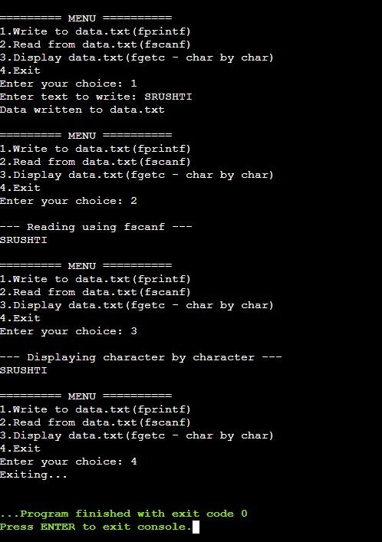
IMPLEMENT
This program effectively demonstrates the core concepts of C file handling using three different methods of reading and writing data:
1. Formatted writing (fprintf)
2. Formatted reading (fscanf)
3. Character-by-character reading (fgetc)

It teaches:
How to create, write, and read files.
The importance of file pointers.

